19th June 2017

All set for the WTCC Race of Portugal

The FIA World Touring Car Championship, which boasts the Japanese tyre manufacturer as exclusive tyre supplier, resumes at the weekend following the excitement and drama witnessed at the Nurburgring, Germany last month. This time, the hot weather and sunshine could be a significant factor as the track gladiators race in Vila Real’s legendary street circuit in Portugal.

With a lot at stake, favourites such as Tiago Monteiro - on home soil and crowd support are playing catch up to retake the lost lead. For his part Rob Huff will also hope to get valuable points as he confronts the likes of Nicky Catsburg – current leader of the Championship and Chilton who has shown good form so far. Michelisz is another big name to watch out for as his title chances also need a big points grab in Portugal to stay within sight of the prestigious Championship.

The race weekend takes place from the 23rd – 25th June.

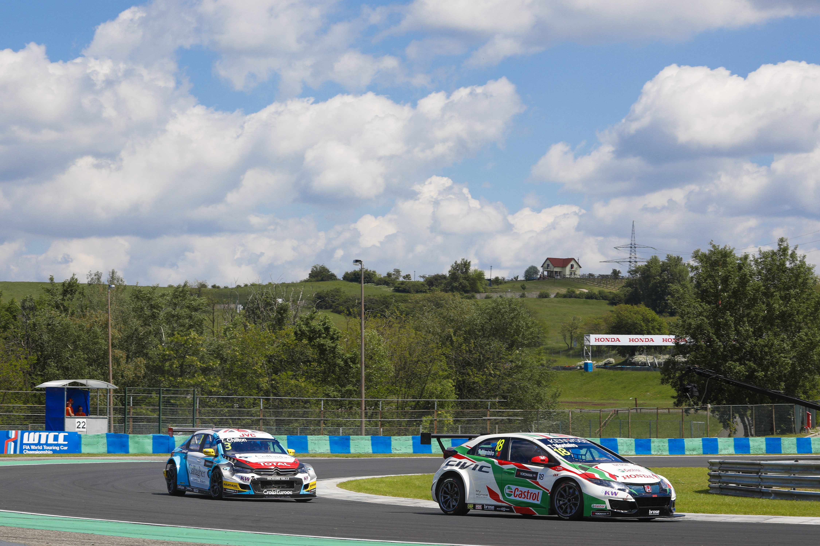
All is set for the WTCC Race of Portugal

